**PORTFOLIO APP**

**HARDWARE REQUIREMENTS:**

|  |  |
| --- | --- |
| **Minimum Requirements** | **Recommended** |
| Windows 7/ Mac OS X 10.8.5 | Windows 10/ Mac OS High Sierra 10.13.4 |
| 2 GB RAM | 4 GB RAM |
| 2 GB Disk Space | 4 GB Disk Space |

**SOFTWARE REQUIREMENTS:**

* Any Operating System (Windows, Linux or Mac)
* Any Web Browser (Chrome, Safari etc.)
* Any Text Editor(Notepad++, Sublime Text, etc.)
* JQueryMobile Libraries

1. jquery.min.js
2. jquery.mobile-1.4.5.js
3. jquery.flip.min.js
4. jquery.flip.min.js.map
5. jquery.mobile-1.4.5.min.css

**TECHNOLOGIES UESD:**

* HTML5
* CSS3
* JQuery
* JQueryMobile
* Javascript
* JSON

**SCREENSHOTS:**

1. **Home Page:** This is the home page. This page will reflect first when application starts.



1. **Side Menu:** This will open by clicking on the “sandwich menu” at the top-left corner of all the pages. This page contains links to all the pages in the application. This is a toggle-panel.

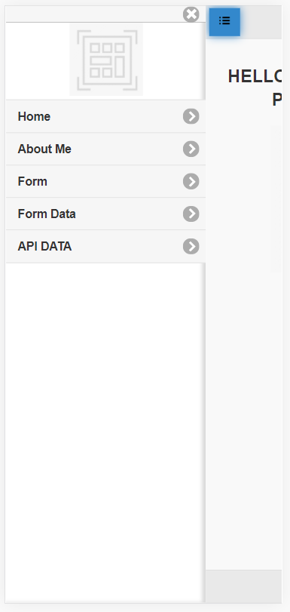

1. **About Me Page:** Touch based flip card is implemented in this page. By clicking on the image, image will flip and image with description will appear.

** **

1. **Form Page:** This pages allows user to add various details like First name, last name, gender, description about themselves, etc. By clicking on the “SUBMIT” button, data will be stored in local storage of browser.

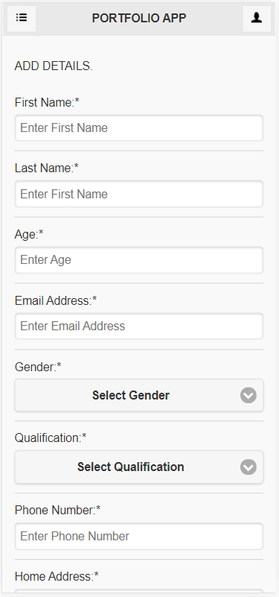 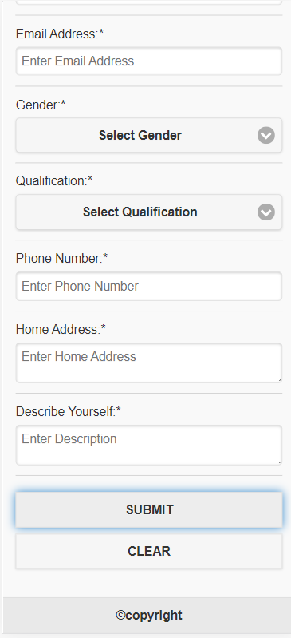

**Form Validations:** All fields are mandatory. If user left any field filled, dialog box will appear and shows error.

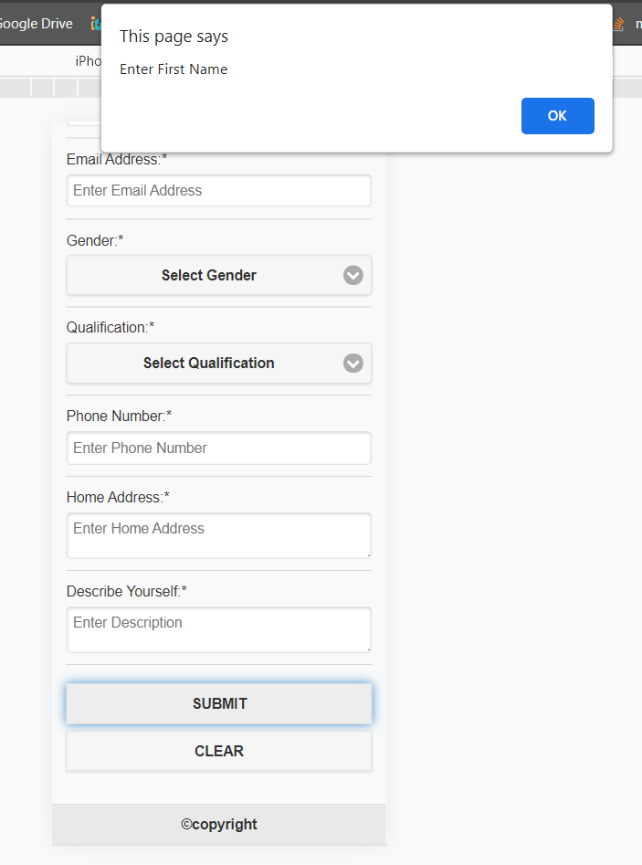

1. **Form Data Page:** Data entered through FORM PAGE will be displayed in this page in tabular form.

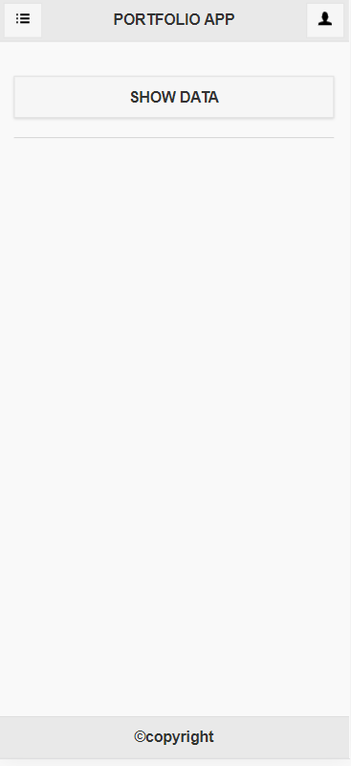 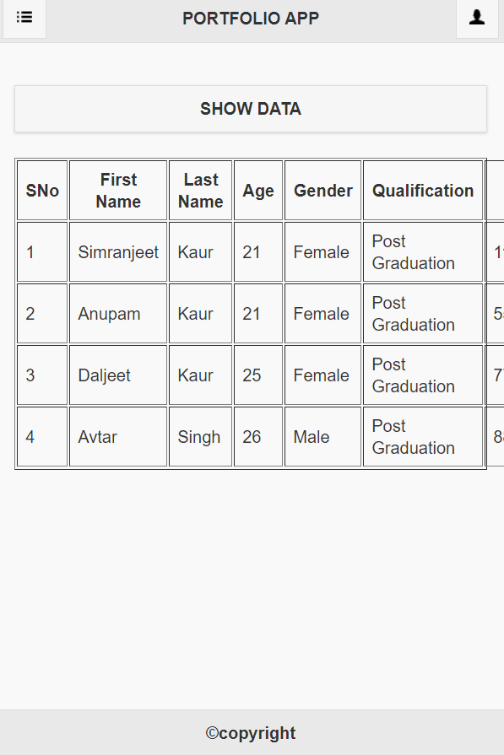

1. **API Data Page:** This page will show the data of weather of New York city. This data is fetched using JSON API naming “Weather Api by OPENWEATHER”.

